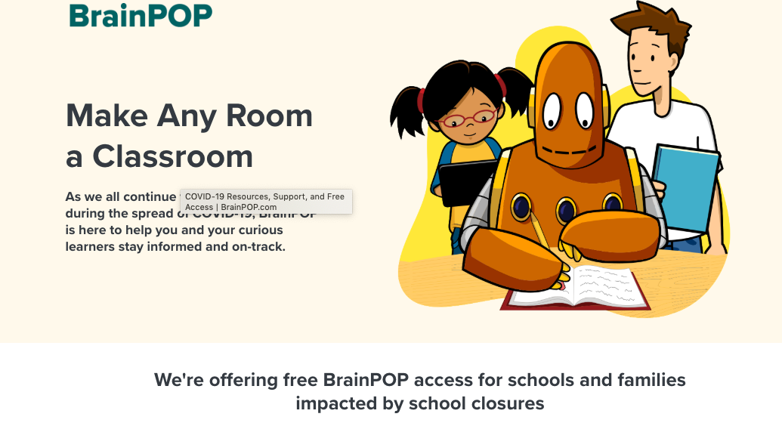

As we all work to keep our kids engaged, learning, and growing, PCEF is collecting a list of resources for you to reference whenever you might need it!

Please feel free to send us additional links; we’ll be happy to take a look at them and add them to our list.

* First, a link to our own [Park City School District resource list](http://www.pcschools.us/departments/teaching-and-learning/teaching-and-learning/#1584374878451-71e1d9e6-c823), with a caveat that students prioritize work assigned by teachers first.
* Scholastic has created a [free learn-from-home site](https://classroommagazines.scholastic.com/support/learnathome.html) with 20+ days of learning and activities.
* Park City Library has a [list of e-resources](https://parkcitylibrary.org/eresources-for-children/) with links to videos, e-books, and e-audiobooks.
* Pretend to travel the world! [Go on a virtual tour of these 12 famous museums](https://www.travelandleisure.com/attractions/museums-galleries/museums-with-virtual-tours).
* Awesome free curriculum - everything from preschool activities to 12th grade is [here](https://allinonehomeschool.com/).
* List of [thinking games by grade](https://allinonehomeschool.com/thinking/).
* A great blog post from the Thomas B. Fordham Institute with nearly 2 dozen additional resources [can be found here](https://fordhaminstitute.org/national/commentary/resources-learning-home-during-covid-19-school-closures?mc_cid=31a7a1a0e8&mc_eid=70a3e8a755).

**YouTube Channels:**

* [Park City Library](https://www.youtube.com/channel/UCJGzYzwMO_7VsV2eQj8Ry2A)
* [Crash Course Kids](https://www.youtube.com/user/crashcoursekids)
* [Science Channel](https://www.youtube.com/user/ScienceChannel)
* [SciShow Kids](https://www.youtube.com/user/scishowkids)
* [National Geographic Kids](https://www.youtube.com/channel/UCXVCgDuD_QCkI7gTKU7-tpg)
* [Free School](https://www.youtube.com/user/watchfreeschool)
* [Geography Focus](https://www.youtube.com/channel/UC8HYERScBt-e0kV0fpe0asg)
* [TheBrainScoop](https://www.youtube.com/user/thebrainscoop)
* [SciShow](https://www.youtube.com/user/scishow)
* [Kids Learning Tube](https://www.youtube.com/channel/UC7EFWpvc1wYuUwrtZ_BLi9A)
* [Geek Gurl Diaries](https://www.youtube.com/user/GeekGurlDiaries)
* [Mike Likes Science](https://www.youtube.com/user/comaniddy)
* [Science Max](https://www.youtube.com/channel/UCbprhISv-0ReKPPyhf7-Dtw)
* [SoulPancake](https://www.youtube.com/user/soulpancake)

**Online resources:**

* [BrainPop](https://go.brainpop.com/COVID19?utm_source=covidhub&utm_medium=hero&utm_campaign=coronavirus&utm_content=free-access)
* [Curiosity Stream](https://curiositystream.com/)
* [Tynker](https://www.tynker.com/parents/)
* [Outschool](https://outschool.com/)
* [Udemy](https://www.udemy.com/)
* [iReady](https://www.curriculumassociates.com/products/i-ready)
* [Beast Academy](https://beastacademy.com/)
* [Khan Academy](https://www.khanacademy.org/)
* [Creative Bug](https://www.creativebug.com/)
* [Discovery Education](https://www.discoveryeducation.com/)

**More free learning websites:**

* [Starfall Education](https://www.starfall.com/h/)
* [ABCya!](https://www.abcya.com/)
* [FunBrain](https://www.funbrain.com/)
* [SplashLearn](https://www.splashlearn.com/)
* [Storyline Online](https://www.storylineonline.net/)
* [PBS Kids](https://pbskids.org/)
* [Highlights Kids](https://www.highlightskids.com/)
* [National Geographic Kids](https://kids.nationalgeographic.com/)
* [Cool Math 4 Kids](https://www.coolmath4kids.com/)
* [Math Game Time](http://www.mathgametime.com/)
* [Unite for Literacy](https://www.uniteforliteracy.com/)
* [Literactive](http://www.literactive.com/Home/index.asp)
* [Science for Kids](http://www.sciencekids.co.nz/)
* [Switch Zoo Animal Games](https://www.switchzoo.com/)
* [Suessville](https://www.seussville.com/)
* [Turtle Diary](https://www.turtlediary.com/)
* [E-Learning for Kids](https://www.e-learningforkids.org/)

We are all in this together, Park City! YOU GOT THIS!